# Visualization and Evaluation of Results

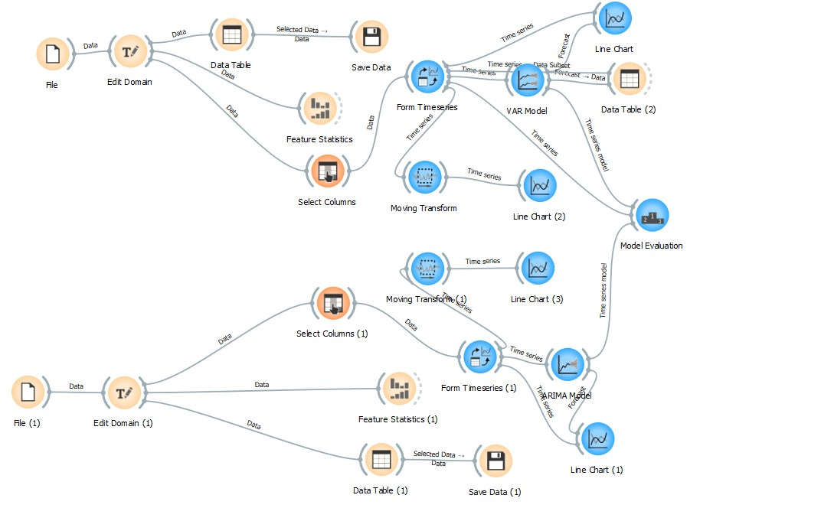

## Descriptive and predictive analysis

Descriptive analysis is done using the statistics of the features and moving transform, and predictive analysis is done using the Arima and var models.

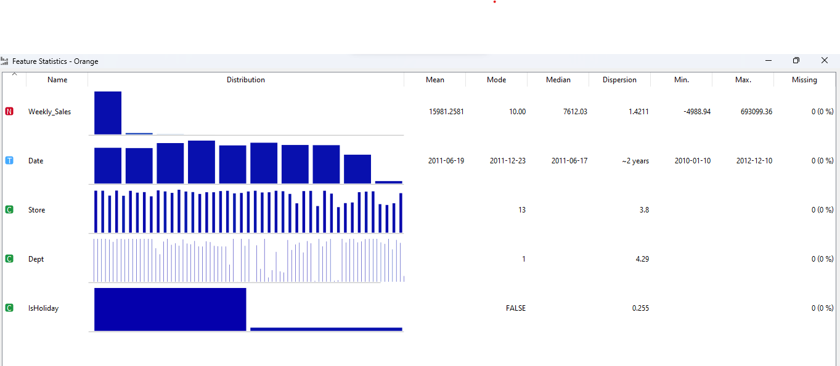

In the first descriptive analysis technique, the description of all the attributes of the first csv is shown on the basis of the weekly sales. According to it, the first dataset shows that the weekly sales of the total store vary according to the mean, mode and median value. There are several departments present in the store, and the sales are higher during holidays, and during non-holiday times, the sales are lower.

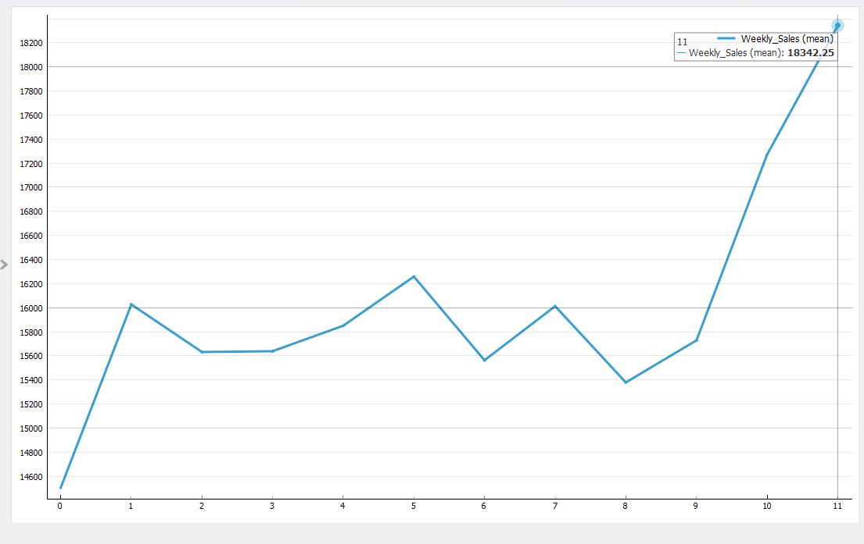

In the moving transform result, the line graph is made, which shows the result of the trend increasing in the last month of the year due to the large number of holidays present in the dataset. Last month's sales were estimated at around 18342.25, and this is the highest among all.

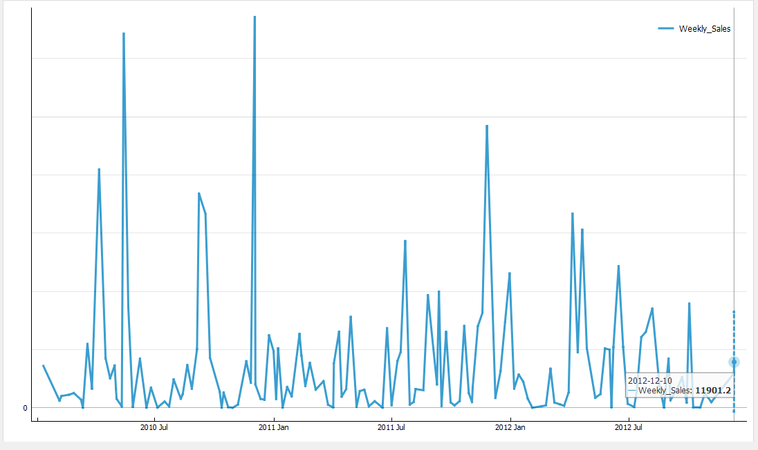

The last description, that is, the predictive analysis, shows the forecasting of the next season in the year 2012 – 12 – 10. The weekly sales are forecasted at around 11901.2.

For the second csv file, the description of all the attributes of the second csv is shown on the basis of the weekly sales (Katrakazas et al., 2020).

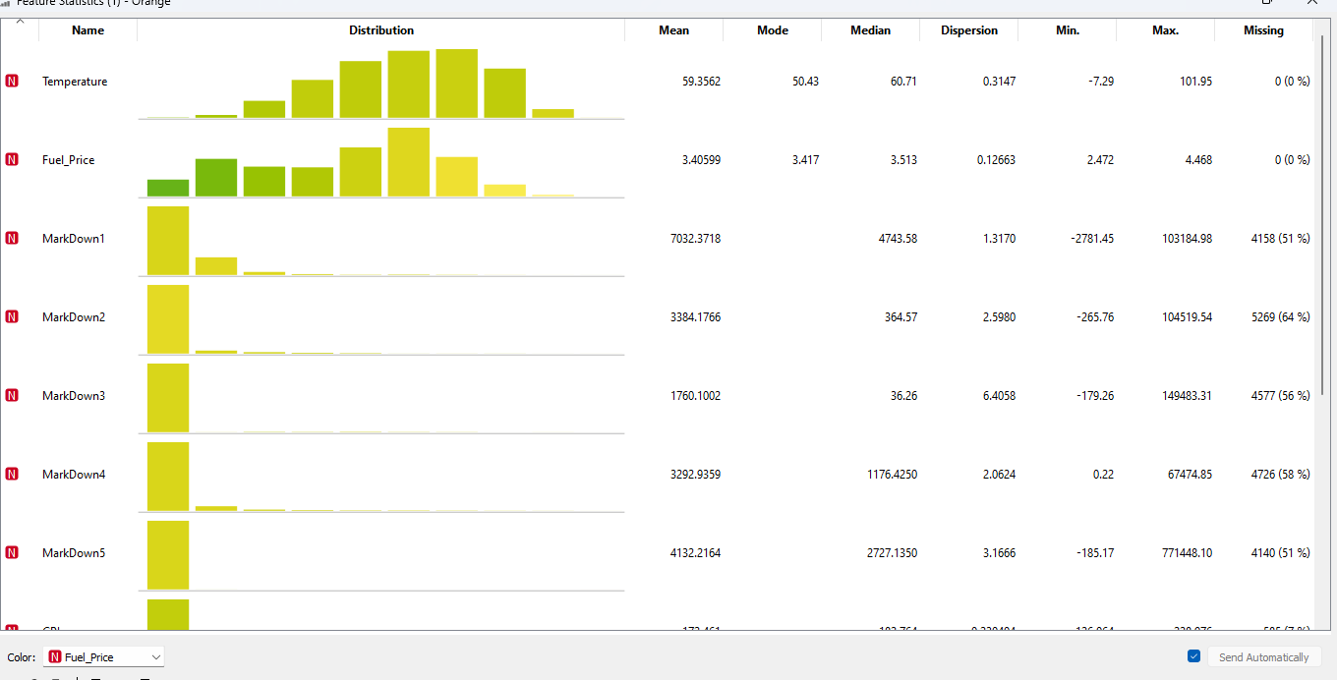

According to it, the first dataset shows that the fuel price of the total store varies according to the mean, mode and median value. There are several marks present in the store, and the temperature and the other attributes information are shown in the following feature statistics result.

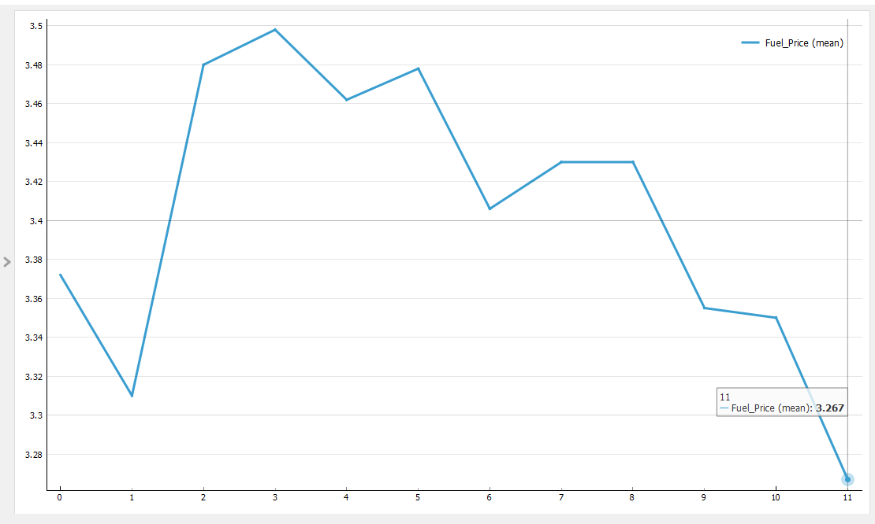

In the moving transform result, the line graph is made, which shows the result of the trend decreasing in the last month of the year due to the large number of holidays present in the dataset and the people who went to the store also. Last month's sales were estimated at around 3.267, and this is the lowest among all (Dama and Sinoquet, 2021).

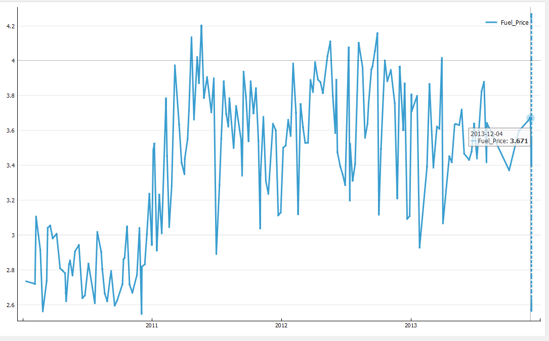

The last description, that is, the predictive analysis, shows the forecasting of the next season in the year 2013 – 12 – 04. The fuel price is forecasted to be around 3.671 (TR et al., 2022).

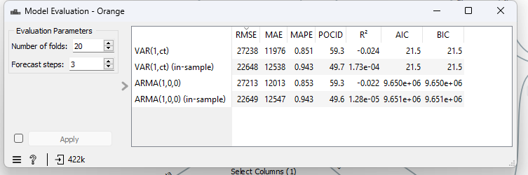

The var model accuracy is slightly more than the Arima model, so it is clear from the model evaluation that the Arima model is less significant than the var model.

## Model and significance of the model

The three models are used in the following scenario, and their significance is shown below.

1. ARIMA (AutoRegressive Integrated Moving Average)

* Apply an ARIMA model to your time series data, and select proper orders p d q.
* Divide your data into training and testing sets.
* Use the trained model to predict future values.
* Compare actual values with forecasted ones in the testing set.
* Use metrics such as Mean Squared Error (MSE) and Meal Absolute Error(MAE) to assess the model performance (Benvenuto et al., 2020).

2. VAR (Vector Autoregression)

* + Fit a VAR model for your multivariate time series data.
  + Like ARIMA, divide your data into training and testing sets.
  + Predict future values using the trained VAR model.
  + Use relevant metrics for multivariate time series, such as Mean Squared Error (MSE), to assess the forecast accuracy (Haslbeck, Bringmann and Waldorp, 2020).

3. Transform Moving Model (Assuming you mean a moving average model):

* + Plot a moving average model to your time series data.
  + Divide your data into training and testing datasets.

To predict future values, utilize the trained moving average model